Functions in python:

Inbuilt function

User defined function

Parameter:

ARGUMENTS AND ITS TYPES:

Default,positional,keyword,pointer(arbitrary):

<https://www.geeksforgeeks.org/python-functions/>

example:

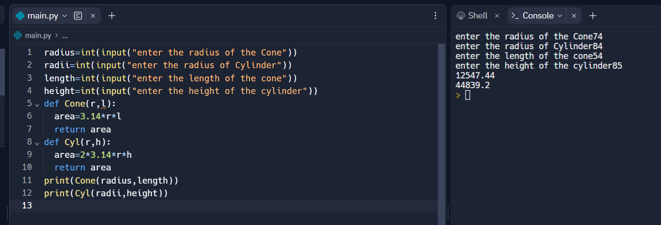

Factorial”

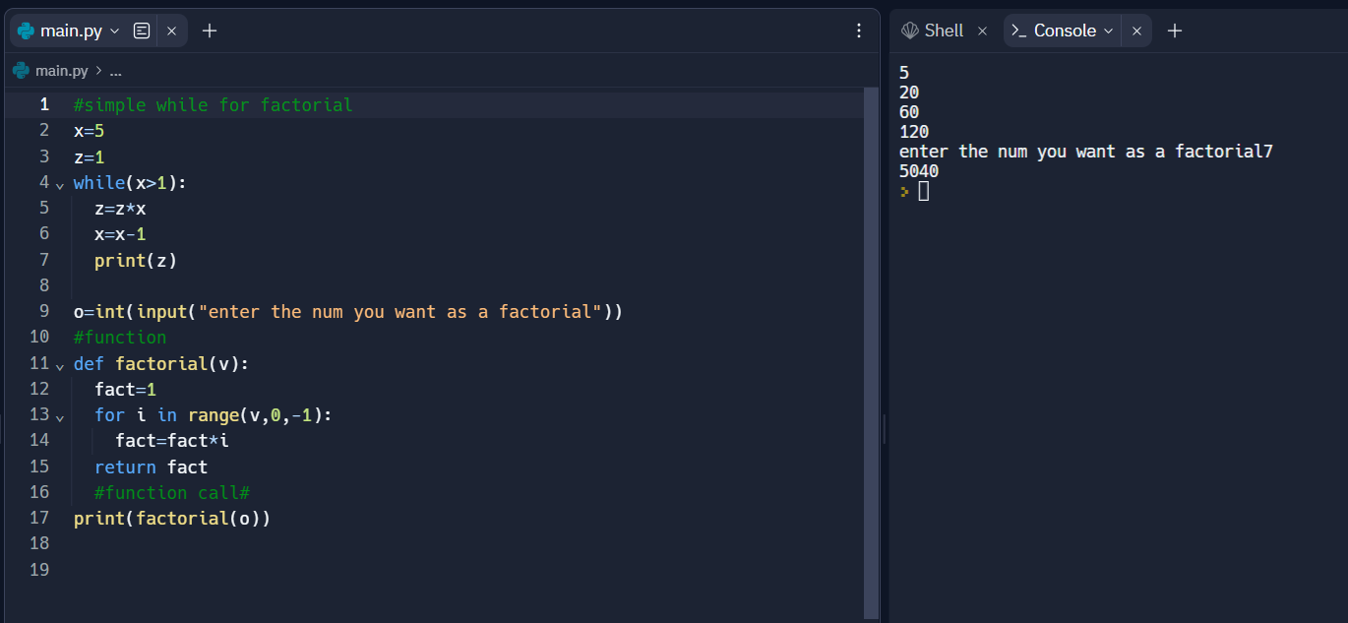

Returning types:

returns the control to the calling function.

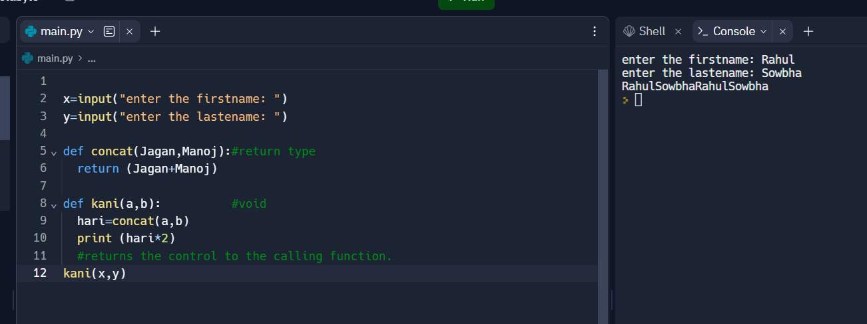

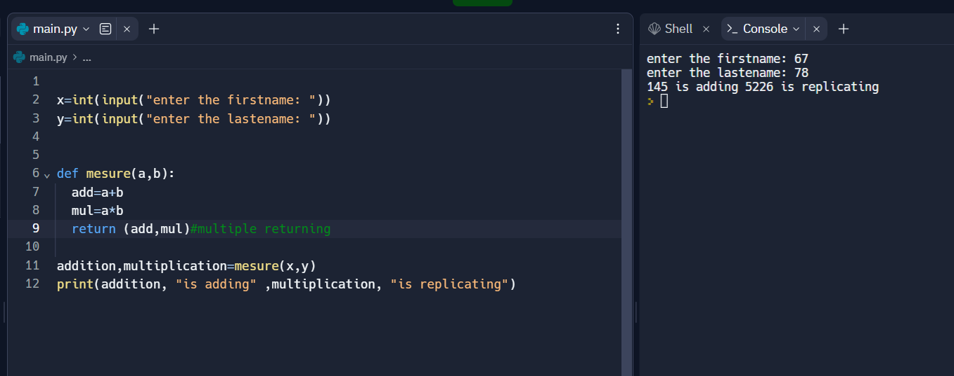

Global and local variable:

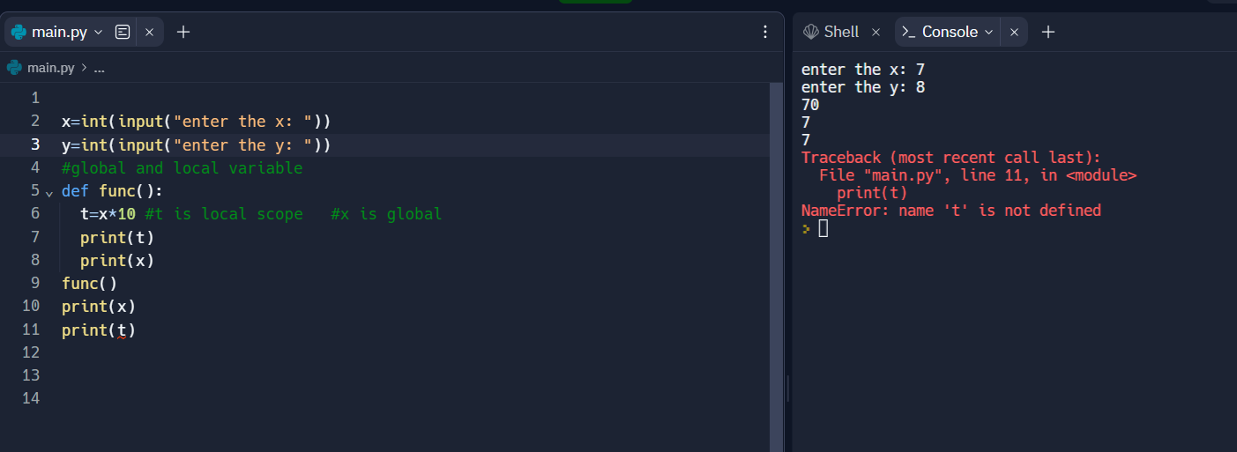

Modules:

Modules is a group of funcitons.

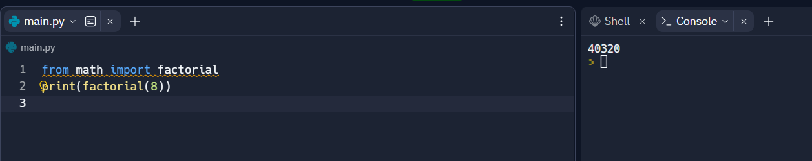

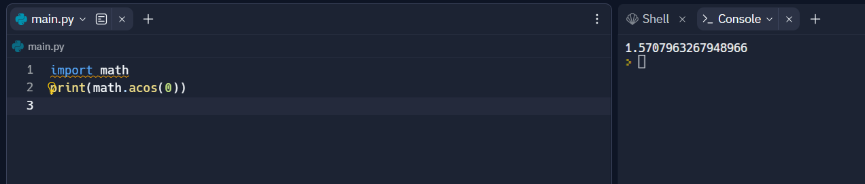

USER DEFINED MODULE:

